BRACT’s
Vishwakarma Institute of Information Technology, Pune Practical Implementation Sheet
Department: CS-AI Semester: 5 Academic Year: 2026-27
Division: E Batch: 2 Practical No:8 Roll no: 66 PRN No: 12411609
Subject Name: Deep Learning
Name of Student: Laukika Shinde
Problem Statement: Implement Pretrained BERT Model for sentiment analysis or text classification on a sample dataset.

Algorithm:
Step 1: Import the required libraries such as PyTorch, Transformers, Datasets, NumPy, Pandas, Matplotlib, and Scikit-learn.

Step 2: Load the IMDb movie-review dataset containing positive and negative reviews.

Step 3: Load the pretrained BERT (bert-base-uncased) tokenizer from Hugging Face.

Step 4: Tokenize the text reviews using the BERT tokenizer with padding, truncation, and a maximum sequence length of 128.

Step 5: Load the pretrained BERT model for sequence classification with two output classes: Positive and Negative.

Step 6: Divide the dataset into training and testing subsets.

Step 7: Configure the BERT training parameters such as learning rate, batch size, number of epochs, and weight decay.

Step 8: Fine-tune the pretrained BERT model on the IMDb training dataset.

Step 9: Evaluate the trained model using accuracy and F1-score. Step 10: Generate predictions for new user-provided movie reviews. Step 11: Display the predicted sentiment and confidence score.
Step 12: Generate a confusion matrix and classification report to analyze model performance.

Step 13: Save the fine-tuned BERT model and tokenizer for future use.

Code:

# Cell 1: Install required libraries
!pip -q install -U transformers datasets evaluate accelerate print("Required libraries installed successfully.")
# Cell 2: Import required libraries import os
import tarfile
import urllib.request import random import numpy as np import pandas as pd import torch
import matplotlib.pyplot as plt

from datasets import Dataset, DatasetDict from transformers import (
BertTokenizer, BertForSequenceClassification, TrainingArguments,
Trainer
)
import evaluate

from sklearn.metrics import ( confusion_matrix, ConfusionMatrixDisplay, classification_report
)

print("PyTorch version:", torch. version ) print("CUDA available:", torch.cuda.is_available())

if torch.cuda.is_available():
print("GPU:", torch.cuda.get_device_name(0)) # Cell 3: Set random seeds
SEED = 42

random.seed(SEED) np.random.seed(SEED) torch.manual_seed(SEED)

if torch.cuda.is_available(): torch.cuda.manual_seed_all(SEED)

print("Random seed set to:", SEED) # Cell 4: Download the IMDb dataset
DATA_URL = "https://ai.stanford.edu/~amaas/data/sentiment/aclImdb_v1.tar.gz" ARCHIVE_PATH = "/content/aclImdb_v1.tar.gz"
DATA_DIR = "/content/aclImdb"

if not os.path.exists(DATA_DIR): print("Downloading IMDb dataset...")
urllib.request.urlretrieve(DATA_URL, ARCHIVE_PATH) print("Download completed.")

print("Extracting dataset...")
with tarfile.open(ARCHIVE_PATH, "r:gz") as tar: tar.extractall("/content")

print("Extraction completed.") else:
print("IMDb dataset already exists.") print("Dataset directory:", DATA_DIR)
# Cell 5: Read IMDb reviews from text files

def read_reviews(folder): texts = []
labels = []

for label_name, label_value in [("neg", 0), ("pos", 1)]: label_folder = os.path.join(folder, label_name)

for filename in os.listdir(label_folder): if filename.endswith(".txt"):
filepath = os.path.join(label_folder, filename)

with open(filepath, "r", encoding="utf-8") as f: texts.append(f.read())

labels.append(label_value) return texts, labels

train_texts, train_labels = read_reviews( os.path.join(DATA_DIR, "train")
)

test_texts, test_labels = read_reviews( os.path.join(DATA_DIR, "test")
)

print("Total training reviews:", len(train_texts)) print("Total testing reviews:", len(test_texts))

print("\nFirst review:") print(train_texts[0][:1000])

print("\nFirst review label:")
print("Positive" if train_labels[0] == 1 else "Negative") # Cell 6: Create Pandas DataFrames
train_df = pd.DataFrame({ "text": train_texts, "label": train_labels
})

test_df = pd.DataFrame({ "text": test_texts, "label": test_labels
})

print("Training DataFrame shape:", train_df.shape) print("Testing DataFrame shape:", test_df.shape)

print("\nTraining label distribution:") print(train_df["label"].value_counts().sort_index())
# Cell 7: Create Hugging Face Dataset dataset = DatasetDict({
"train": Dataset.from_pandas(
train_df, preserve_index=False
),
"test": Dataset.from_pandas( test_df, preserve_index=False

)
})

print(dataset)

# Cell 8: Select a smaller subset for faster BERT training

# This makes the assignment practical to run in Google Colab. # 5,000 training + 1,000 testing reviews are used.

train_dataset = dataset["train"].shuffle( seed=SEED
).select(range(5000))

test_dataset = dataset["test"].shuffle( seed=SEED
).select(range(1000))

print("Training samples:", len(train_dataset)) print("Testing samples:", len(test_dataset))

# Cell 9: Load pretrained BERT tokenizer model_name = "bert-base-uncased"
tokenizer = BertTokenizer.from_pretrained(model_name)

print("Tokenizer loaded successfully.") print("Model:", model_name) print("Vocabulary size:", tokenizer.vocab_size)
# Cell 10: Tokenize the reviews def tokenize_function(examples):
return tokenizer( examples["text"], padding="max_length", truncation=True, max_length=128
)

tokenized_train = train_dataset.map( tokenize_function,
batched=True
)

tokenized_test = test_dataset.map( tokenize_function, batched=True
)

print("Tokenization completed.") print(tokenized_train)
# Cell 11: Load pretrained BERT for sequence classification model = BertForSequenceClassification.from_pretrained(
model_name, num_labels=2
)

# Label mappings model.config.id2label = {
0: "NEGATIVE",
1: "POSITIVE"
}

model.config.label2id = { "NEGATIVE": 0,
"POSITIVE": 1
}

print("Pretrained BERT model loaded successfully.") print("Number of labels:", model.config.num_labels)

# Cell 12: Define evaluation metrics

accuracy_metric = evaluate.load("accuracy") f1_metric = evaluate.load("f1")

def compute_metrics(eval_pred): logits, labels = eval_pred
predictions = np.argmax(logits, axis=-1) accuracy = accuracy_metric.compute(
predictions=predictions, references=labels
)
f1 = f1_metric.compute( predictions=predictions,

references=labels, average="weighted"
)

return {
"accuracy": accuracy["accuracy"], "f1": f1["f1"]
}

print("Evaluation metrics configured.") # Cell 13: Configure training parameters
training_args = TrainingArguments( output_dir="/content/bert_sentiment_results",

eval_strategy="epoch", save_strategy="epoch",

learning_rate=2e-5,

per_device_train_batch_size=8, per_device_eval_batch_size=8,

num_train_epochs=2, weight_decay=0.01, logging_steps=100, load_best_model_at_end=True, report_to="none",
fp16=torch.cuda.is_available()
)

print("Training configuration created successfully.") # Cell 14: Create Hugging Face Trainer
trainer = Trainer( model=model, args=training_args,

train_dataset=tokenized_train,

eval_dataset=tokenized_test, processing_class=tokenizer,
compute_metrics=compute_metrics
)
print("Trainer initialized successfully.") # Cell 15: Train the BERT model print("Starting BERT fine-tuning...")
print("This may take several minutes depending on the Colab GPU.") train_result = trainer.train()
print("\nTraining completed successfully!") # Cell 16: Evaluate the model evaluation_results = trainer.evaluate()
print("BERT Evaluation Results") print("=" * 40)

for key, value in evaluation_results.items(): print(f"{key}: {value}")
# Cell 17: Generate predictions on the test dataset prediction_output = trainer.predict(tokenized_test) predicted_labels = np.argmax(
prediction_output.predictions, axis=1
)
actual_labels = prediction_output.label_ids print("Prediction completed.")
print("Number of predictions:", len(predicted_labels)) # Cell 18: Classification report
print("Classification Report") print("=" * 60)

print(
classification_report( actual_labels, predicted_labels,
target_names=["Negative", "Positive"]
)
)
# Cell 19: Confusion matrix cm = confusion_matrix(
actual_labels, predicted_labels
)

disp = ConfusionMatrixDisplay( confusion_matrix=cm, display_labels=["Negative", "Positive"]
)

disp.plot()
plt.title("BERT Sentiment Analysis - Confusion Matrix") plt.show()
# Cell 20: Function for custom sentiment prediction def predict_sentiment(text):
inputs = tokenizer( text, return_tensors="pt", truncation=True, padding=True, max_length=128
)
device = model.device inputs = {
key: value.to(device)
for key, value in inputs.items()
}

model.eval()

with torch.no_grad():

outputs = model(**inputs)

probabilities = torch.softmax( outputs.logits,
dim=-1
)

prediction = torch.argmax( probabilities,
dim=-1
).item()

labels = {
0: "Negative",
1: "Positive"
}

sentiment = labels[prediction]
confidence = probabilities[0][prediction].item() return sentiment, confidence
# Cell 21: Test a positive review

review = "This movie was absolutely fantastic. The acting and story were excellent." sentiment, confidence = predict_sentiment(review)
print("Review:") print(review)

print("\nPredicted Sentiment:", sentiment) print("Confidence:", round(confidence * 100, 2), "%")

# Cell 22: Test a negative review

review = "This movie was terrible and boring. I did not enjoy it at all." sentiment, confidence = predict_sentiment(review)
print("Review:") print(review)

print("\nPredicted Sentiment:", sentiment) print("Confidence:", round(confidence * 100, 2), "%")

# Cell 23: Test multiple custom reviews

reviews = [
"I really enjoyed this movie. It was amazing!", "The movie was boring and poorly made.", "Excellent acting and a wonderful storyline.", "I regret watching this movie. It was terrible.", "The movie was okay but nothing special."
]

print("BERT SENTIMENT ANALYSIS")
print("=" * 70)

for review in reviews:
sentiment, confidence = predict_sentiment(review)

print("\nReview:", review) print("Sentiment:", sentiment)
print("Confidence:", round(confidence * 100, 2), "%") # Cell 24: Save the trained model
SAVE_PATH = "/content/bert_sentiment_model"

trainer.save_model(SAVE_PATH) tokenizer.save_pretrained(SAVE_PATH)

print("Model saved successfully.") print("Location:", SAVE_PATH)

# Cell 25: Load the saved model

loaded_tokenizer = BertTokenizer.from_pretrained( SAVE_PATH
)

loaded_model = BertForSequenceClassification.from_pretrained( SAVE_PATH
)

print("Saved BERT model loaded successfully.") # Cell 26: Test the saved model
def predict_with_saved_model(text):

device = torch.device(
"cuda" if torch.cuda.is_available() else "cpu"
)

loaded_model.to(device) loaded_model.eval()

inputs = loaded_tokenizer( text, return_tensors="pt", truncation=True, padding=True, max_length=128
)
inputs = {
key: value.to(device)
for key, value in inputs.items()
}
with torch.no_grad():
outputs = loaded_model(**inputs)

probabilities = torch.softmax( outputs.logits,
dim=-1
)
prediction = torch.argmax( probabilities,
dim=-1
).item() labels = {
0: "Negative",
1: "Positive"
}
print("Text:", text)
print("Predicted Sentiment:", labels[prediction]) print(
"Confidence:", round(
probabilities[0][prediction].item() * 100,
2
),
"%"

predict_with_saved_model(
"The movie was wonderful and I loved every moment of it."

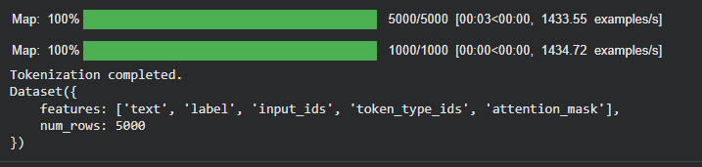
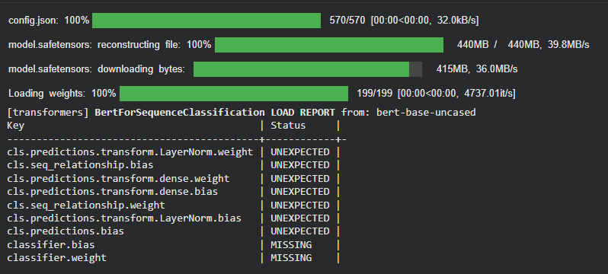
)

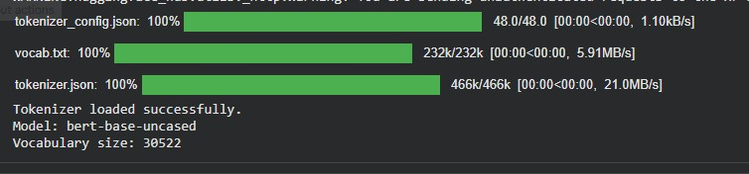
Output:



